**Section D (Relational Algebra)**

1. SELECT Reservation WHERE rdate <= 01-23-2014 AND rdate <= 03-10-2014 GIVING A1

JOIN A1, Boat WHERE A1.bid = Boat.bid GIVING A2

PROJECT A2 OVER bname

* **The Akron Cruiser, Fair Play**

1. SELECT Boat WHERE color = “green” GIVING B1

JOIN B1, Reservation WHERE B1.bid = Reservation.bid GIVING B2

SELECT B2 WHERE rdate = 04-15-2014 GIVING B3

JOIN B3, Sailor WHERE B3.sid = Sailor.sid GIVING B4

PROJECT B4 OVER sname, age

* **Jeffrey Hill, age 44**

1. SELECT Boat WHERE name = “Fair Play” GIVING C1

JOIN C1, Reservation WHERE C1.bid = Reservation.bid GIVING C2

PROJECT C2 OVER rdate, deposit

* **03-10-2014, $200**

1. SELECT Boat WHERE color = “green” GIVING D1

JOIN D1, Reservation WHERE D1.bid = Reservation.bid GIVING D2

JOIN D2, Sailor WHERE D2.sid = Sailor.sid GIVING D3

PROJECT D3 OVER age

* **44**

SELECT Boat WHERE color = “blue” GIVING D4

JOIN D4, Reservation WHERE D4.bid = Reservation.bid GIVING D5

JOIN D5, Sailor WHERE D5.sid = Sailor.sid GIVING D6

PROJECT D6 OVER age

* **23 and 44 (there is not a single person who can reserve a green and blue colored boat)**

1. SELECT Reservation WHERE deposit > 100 GIVING E1

JOIN E1, Sailor WHERE E1.sid = Sailor.sid GIVING E2

PROJECT E2 OVER sname

* **Monica Johnson, Gordon Watson**

1. SELECT Reservation WHERE rdate = null GIVING F1

JOIN F1, Boat WHERE F1.bid = Boat.bid GIVING F2

PROJECT F2 OVER color

* **Red**

**Section E (Entity-Relationship Diagram)**

a. 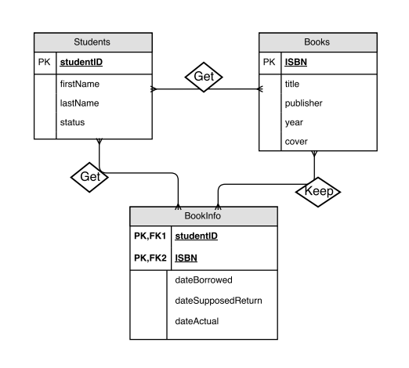

s

b. **Students** (*studentID*: char, firstName: *char*, lastName: *char*, status: *char*)

**Books** (*ISBN*: int, title: *char*, publisher: *char*, year: *int*, cover: *char*)

**BookInfo** (*studentID*: char, *ISBN*: int, dateBorrowed: *date*, dateSupposedReturn: *date*, dateActual: *date*)

